**ENGR 122 Homework 3**



**NOTE:** Use engineering format for problems 1-4. Use non-engineering format for problems 5-8. This is an individual assignment. If you don’t have Mathcad installed yet, then please just work the problems by hand.

1. If the block shown has a mass of 50kg, then what is the tension in cable BC and cable AB? Remember you should always draw a Free Body Diagram as part of your solution. A = 245.17N and C = 424.64N

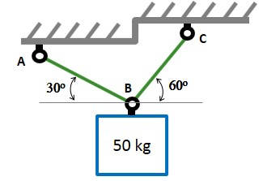

**Given:** θA = 30 degrees

ΘC = 60 degrees

Mblock = 50 kg

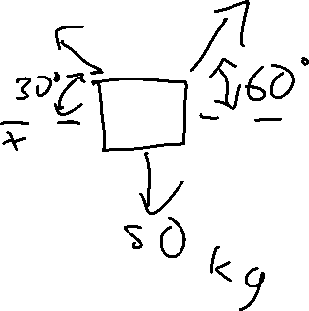

**Request:** FC, FA in Newtons

**Solution:** ∑Fx = FCx - FAx = 0

∑Fx = FCcos(60 deg) - FAcos(30 deg) = 0

FC = FAcos(30 deg) / cos(60 deg)

∑Fy = FCy + FAy - 50kg * 9.8068 m/s2 = 0

= FCsin(60 deg) + FAsin(30 deg) – 490.34 N = 0

(FAcos(30 deg) / cos(60 deg) ) sin(60 deg) + FAsin(30 deg)



= 490.34 N

2FA = 490.34 N

***FA = 245.17 N***

FC = 245.17 * cos(30 deg) / cos(60 deg)

***FC = 424.64680 N***



1. Rework problem 1 using a solve block in Mathcad to compute your answers.







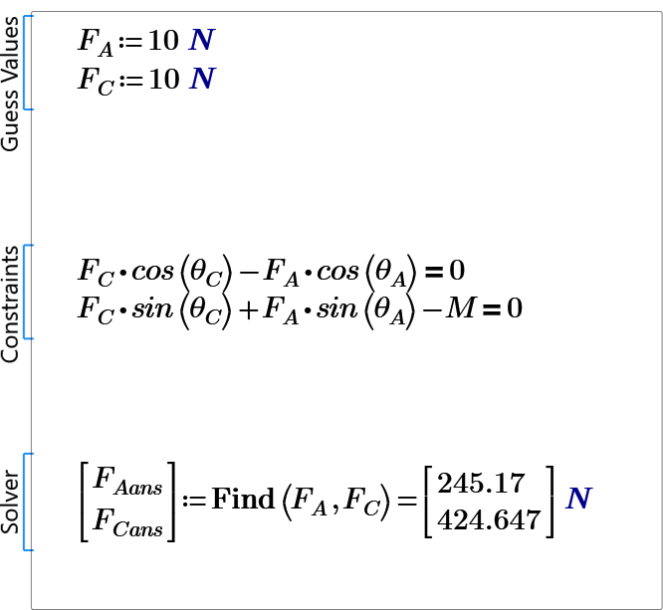

1. A right angle shelf which is tilted 50˚ from the vertical is used as a basketball rack. If the average basketball weighs 6.12N, then what is the force that the rack causes at point A and point B on the basketball? Remember shifting the coordinate system can sometimes make your calculations easier. A = 3.93N and B = 4.69N

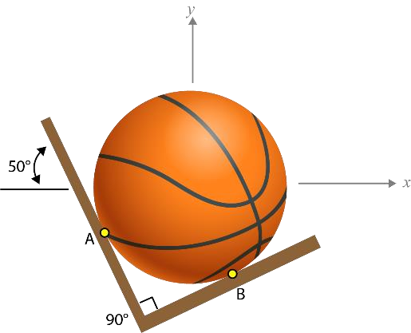

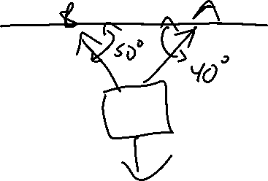

**Given:**  θB = 50 degrees



ΘA = 40 degrees



Fball = 6.12 N

**Request:** FA, FB in Newtons

**Solution:** ∑FX = FAx – FBx = 0

= FAcos(40 deg) – FBcos(50 deg) = 0

FA = FBcos(50 deg) / cos(40 deg)

∑FY = FAy + FBy – 6.12 N = 0

= FAsin(40 deg) + FBsin(50 deg) – 6.12 N = 0

= FBcos(50 deg) / cos(40 deg) * sin(40 deg) + FBsin(50 deg)

* 6.12 N = 0

FBcos(50 deg) / cos(40 deg) * sin(40 deg) + FBsin(50 deg) = 6.12 N

**FB = 4.68819 N**

**FA = 4.68819cos(50 deg) / cos(40 deg) = 3.93386 N**

1. Two flower pots are hanging on a rope as shown. If flower pot 1 weighs 12lbf and flower pot 2 weighs 8lbf, then what is the tension in each of the rope segments? Hint: Break up the image into two separate free body diagrams. AB = 17.4lbf, BC = 14.4lbf, and CD = 17.4lbf



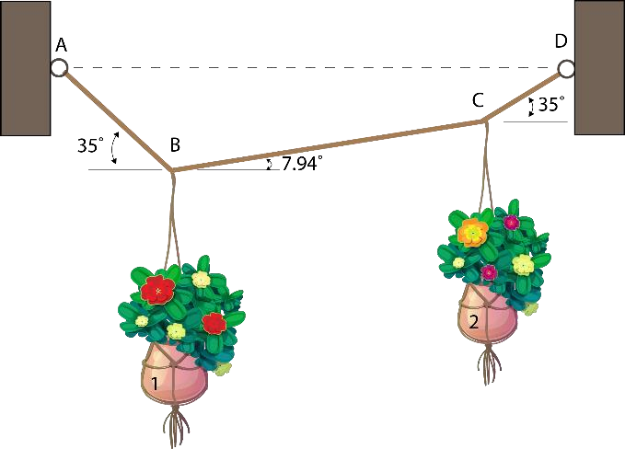

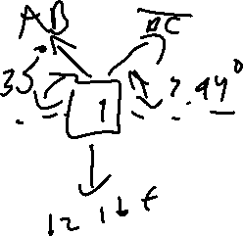

**Given:** F1 = 12 lbf

F2 = 8 lbf

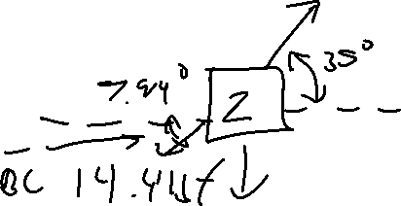

ΘAB, θCD = 35 degrees

ΘBC = 7.94 degrees

**Request:** FAB, FBC, FCD in lbf

**Solution:** ∑FX1 = FBCx – FAbx = 0

= FBCcos(7.94 deg) – FABcos(35 deg) = 0

FBC = FABcos(35 deg) / cos(7.94 deg)



∑FY1 = FBCsin(7.94 deg) + F­ABsin(35) – 12 lbf = 0

FABcos(35 deg)sin(7.94 deg) / cos(7.94 deg) + FABsin(35 deg) = 12 lbf

**FAB = 17.4463 lbf**

**FBC = 17.4463 lbf * cos(35 deg) / cos(7.94 deg) = 14.4295 lbf**

∑FY2 = FCDy – (FBCy + 8) = 0

= F­CDsin(35 deg) – (14.4295sin(7.94 deg) + 8) = 0

FCDsin(35 deg) = 14.4295sin(7.94 deg) + 8

= 22.3761 lbf

**FCD = 22.3761 lbf / sin(35 deg) = 17.4227 lbf**

1. Research accelerometers, like the one showcased in class. Write a few sentences describing how they work. Include some current and potential applications for accelerometers.

Many ways of approaching how to put an accelerometer together have been developed over the years. These ultimate goal in all of these methods is to convert the changes in an object or a set of objects of some analog base to a voltage which is converted into a digital signal. A common way of accomplishing this is through the phenomenon of the piezoelectric effect, which is the act of certain materials generating a voltage upon the application of mechanical stress. Acceleration on some of these materials simulates compression, which causes them to generate small electric discharge. The strength of the signal is converted into a readable acceleration by a computer. An example of a current application of an accelerometer is as a stress testing and diagnostics tool in building automobiles. They can be used to determine if the acceleration of the vehicle at the current fuel intake meets industry or competitive standards. A potential application of an accelerometer is defined in my idea wallet addition.

1. Review the list of sensors/devices that can be checked out for the ENGR 122 project. Choose one to research in more depth. Write a few sentences about how the sensor/device works. Include some potential applications for the sensor/device.

A device available to be checked out for the design projects is the set of RFID chips and the associated RFID scanner. RFID chips work by encoding a hexadecimal or bit string as an array of magnets that generate a unique magnetic field. The scanner interprets the magnetic field and returns the associated information. The information broadcasted by an RFID chip can be passed through an encryption algorithm before being encoded on the chip and decrypted by the scanner with a hash key for optional bonus security. This is useful when using RFID tags for personal identification purposes. Because RFID tags are used on a large scale by transportation agencies, the error rate of information exchange is less than one percent. This makes RFID tags a very reliable method of discrete knowledge transfer. A potential application of RFID tags is as a replacement for current barcode-based store checkout protocol. RFID tags are much easier to identify than barcodes, and could greatly decrease the time spent scanning items in stores.

1. Come up with one idea for your “Idea Wallet” by thinking about something that could be fixed, improved, or developed in a specific field of study (e.g., medicine, transportation, education, business, food, etc.). For your homework, please name the project idea, state the field to which it applies, write up at least a two-sentence description of the idea, and provide pictures/sketches when it makes sense to do so.

The idea I came up with came to me as I was thinking about applications of accelerometers. The idea is for a training glove for boxers and martial artist apprentices that keeps track of punching speeds for someone wearing the glove. It can be used for keeping a goal and monitoring improvement progress. It can also be used to measure how hard hits are by deceleration measured by the accelerometer.

*Since this idea requires you to think of something in a specific field, you may need to talk to someone in that field. You are encouraged to go out and talk with the experts in the field to help you think through some potential project ideas. If you consult someone for project ideas, indicate who you spoke to in your homework.*

NOTE: You don’t need to try to find a solution to the problem at this point!